Truncated Tetrahedron

Definition
# Source: AI Source: Provided by: [Data Path: Persons Table -> ID Column: 1, Name_En Column: Motasem Essam] -> From: [ChatGPT] on [7/25/2026]
A Truncated Tetrahedron is a three-dimensional polyhedron formed by cutting off the four vertices of an original tetrahedron using planes.
The truncation process creates four new triangular faces while modifying the original four triangular faces into hexagonal faces.
A uniformly truncated tetrahedron is an Archimedean solid.

Geometric Structure
# Source: AI Source: Provided by: [Data Path: Persons Table -> ID Column: 1, Name_En Column: Motasem Essam] -> From: [ChatGPT] on [7/25/2026]
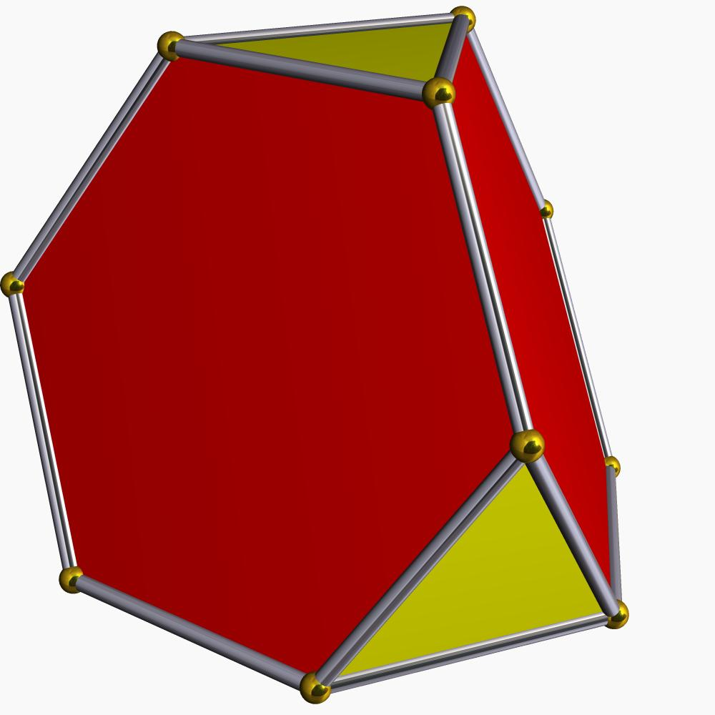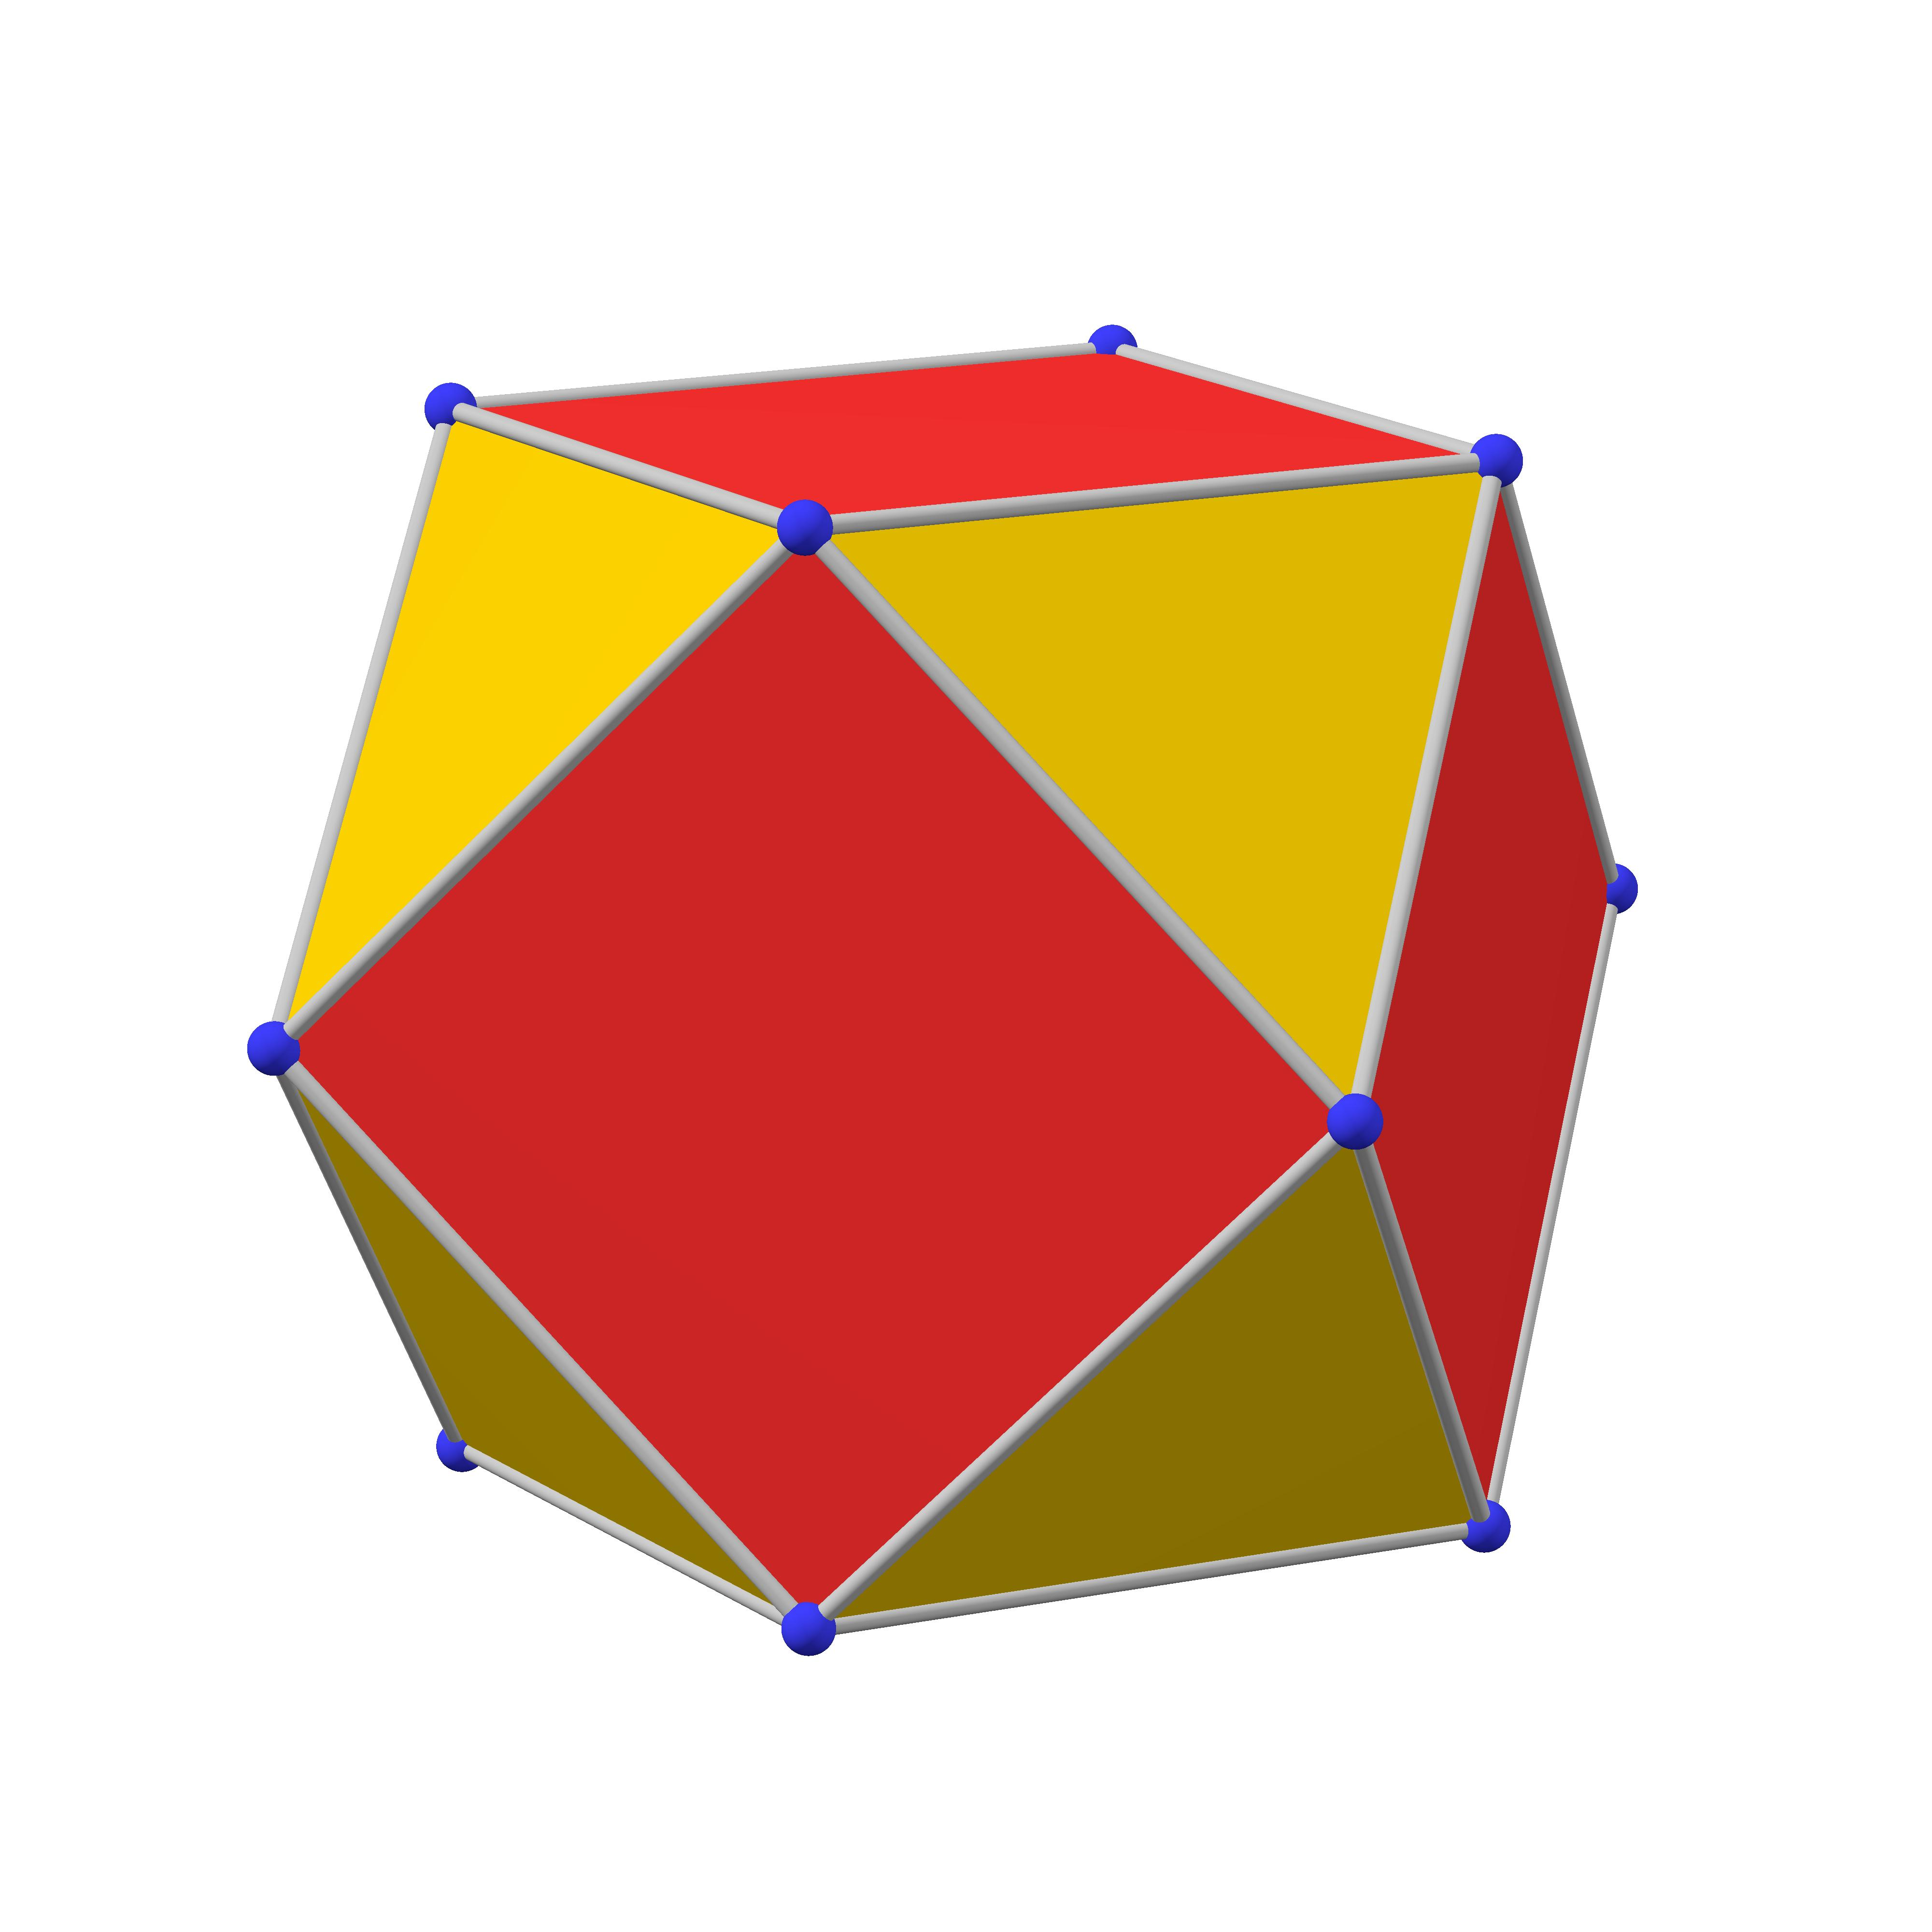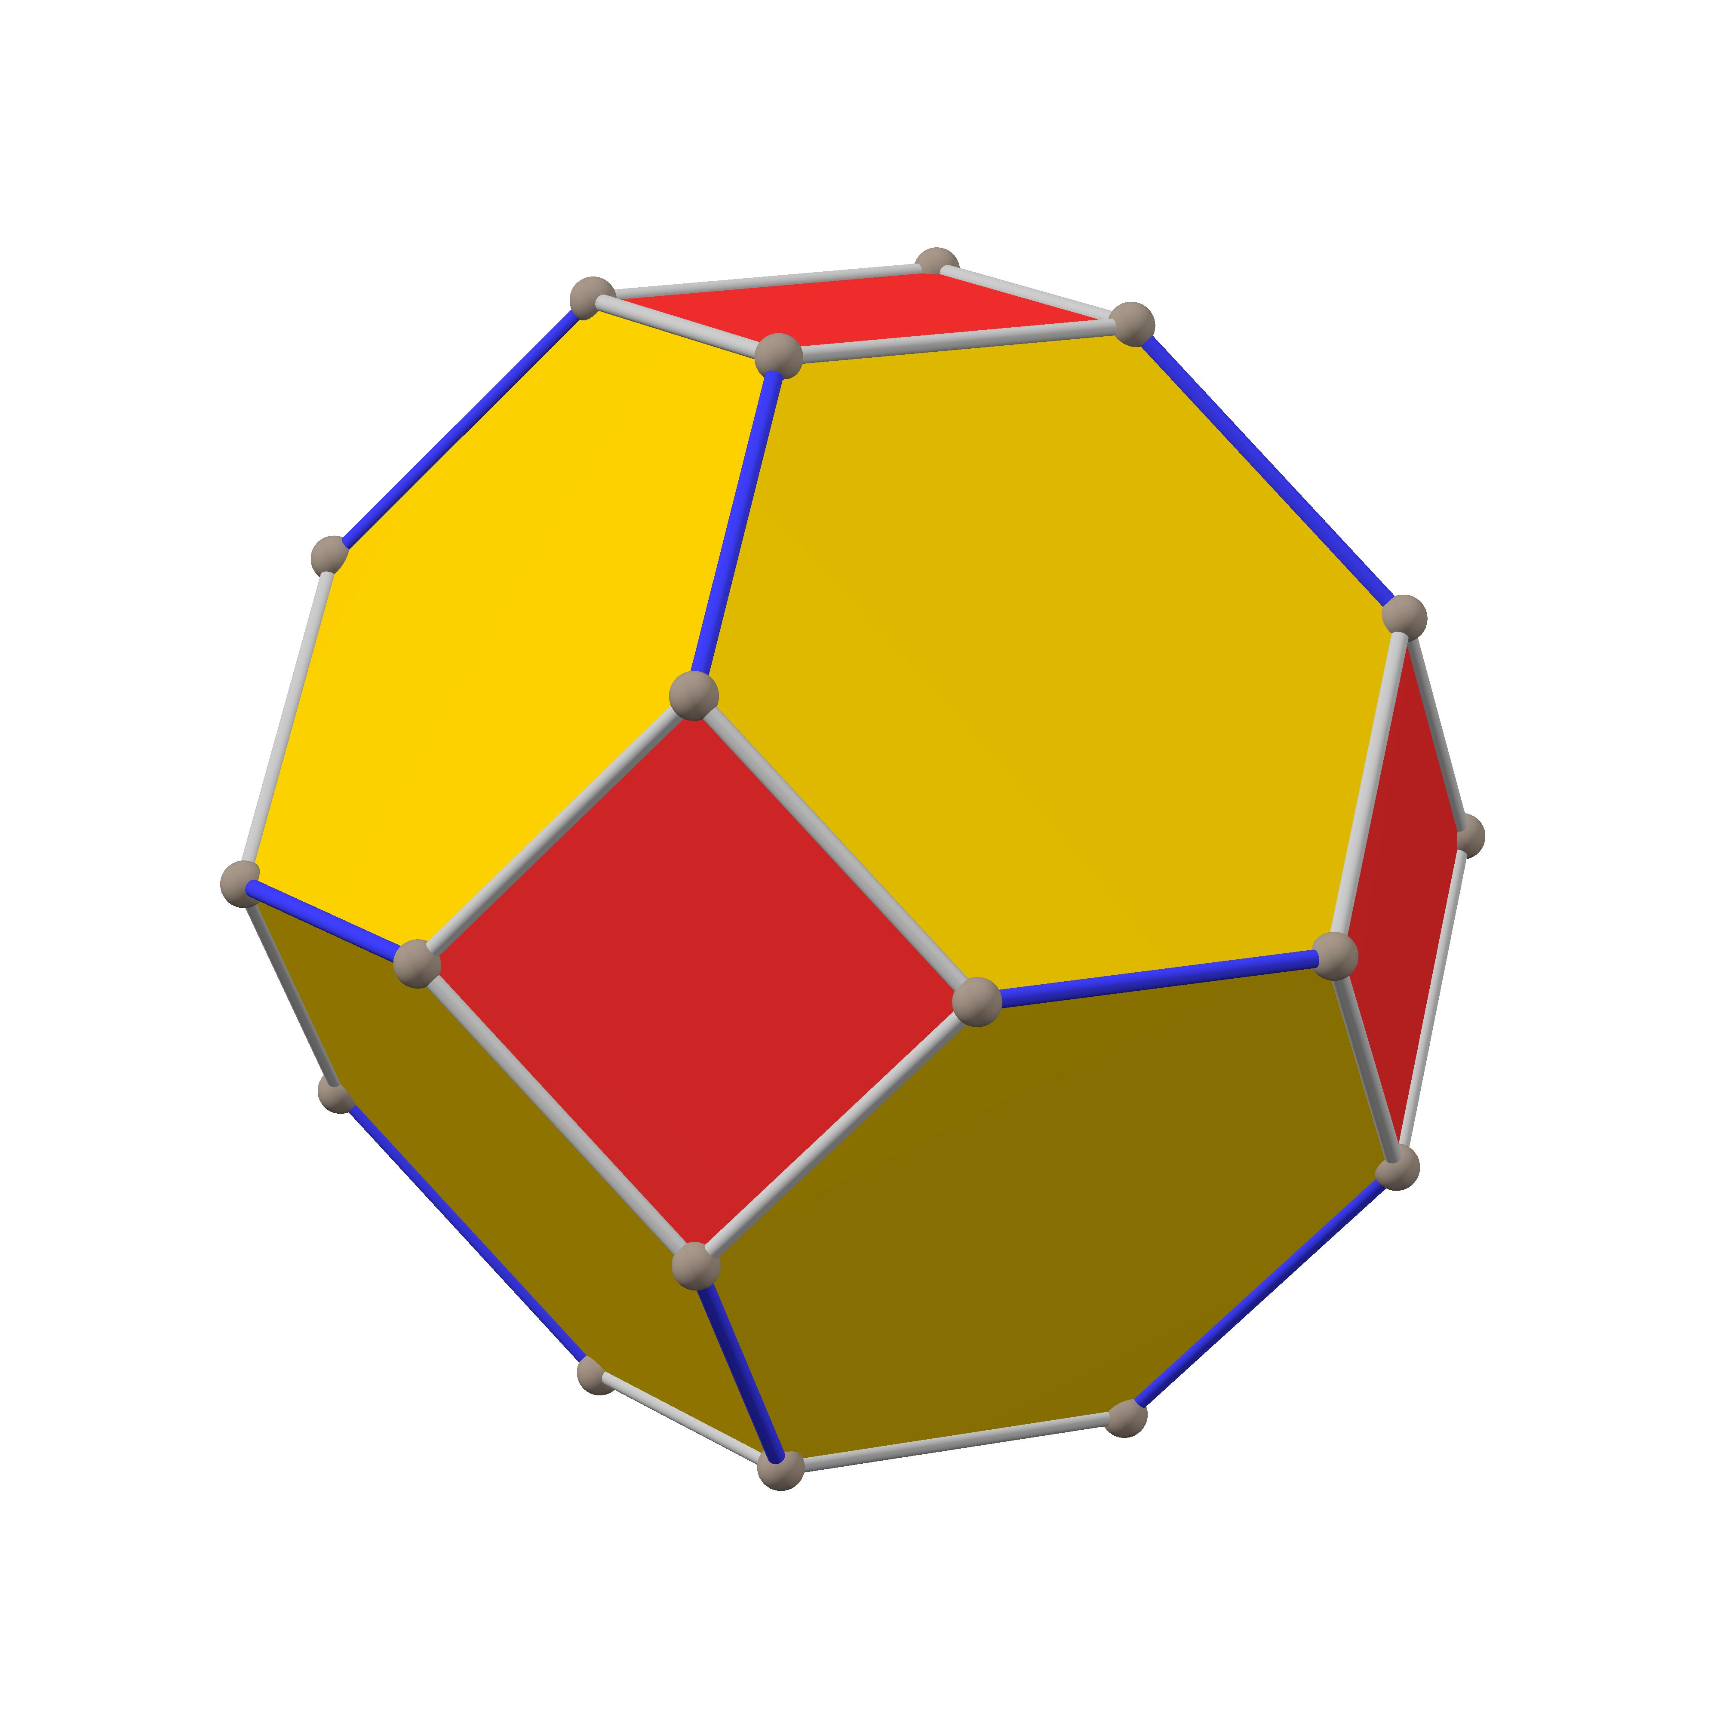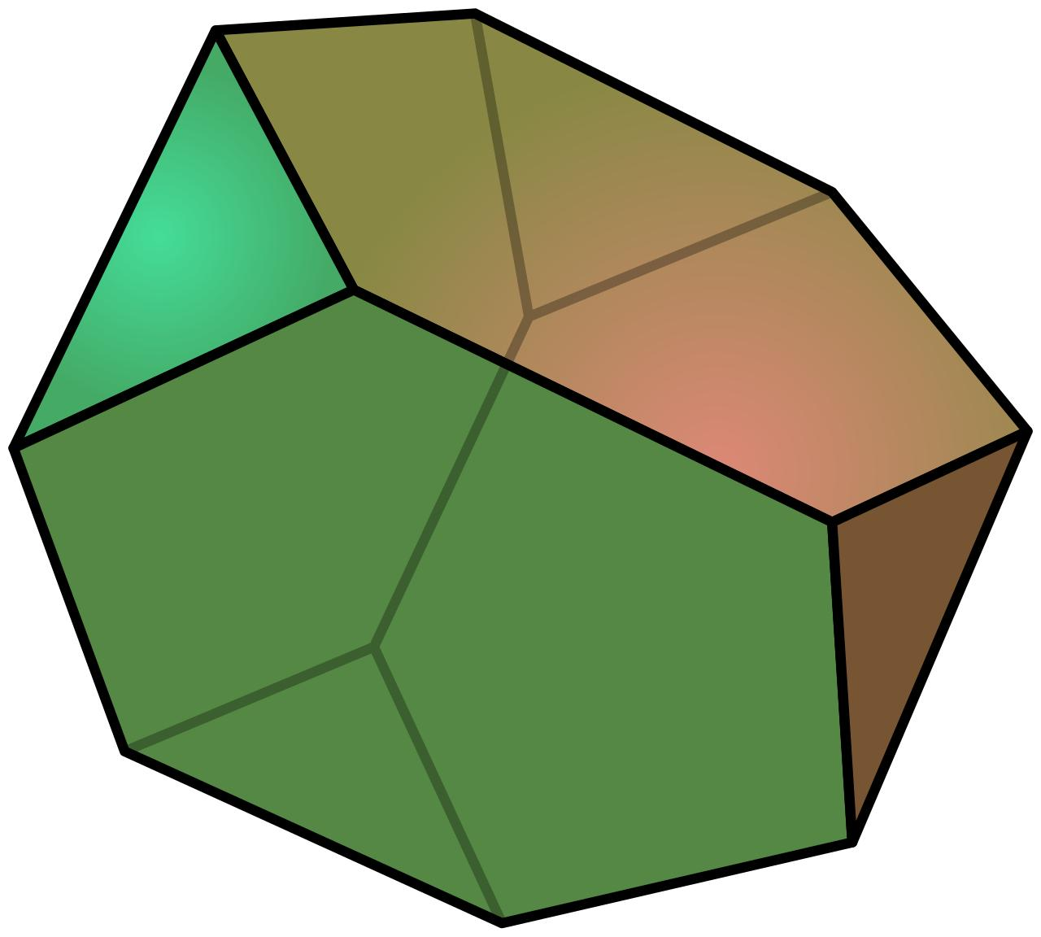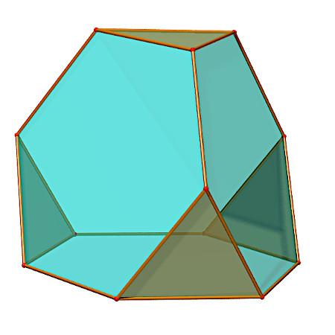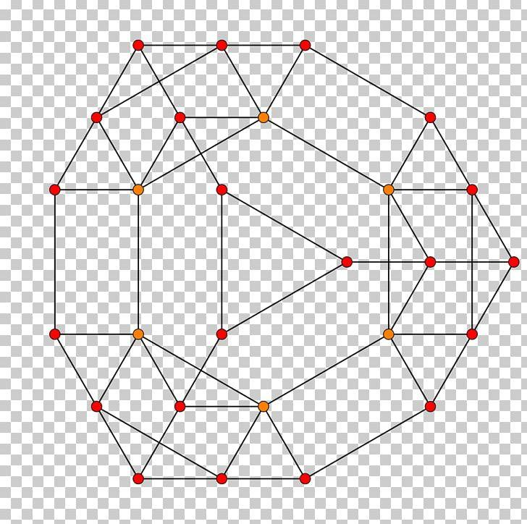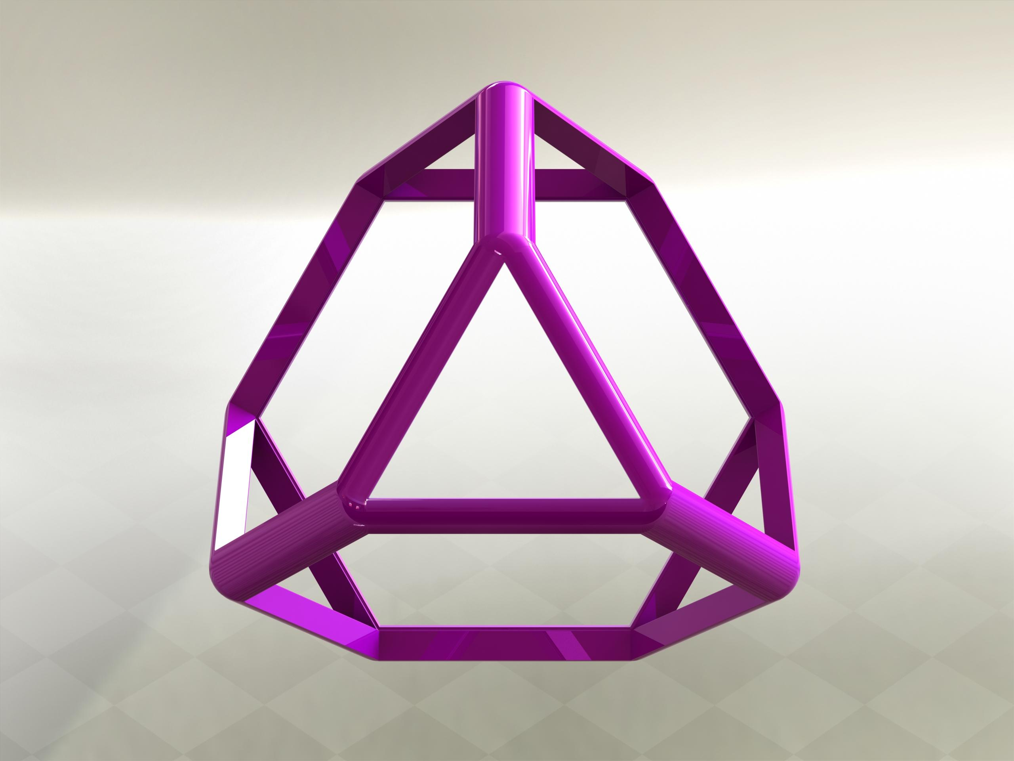
A truncated tetrahedron consists of:
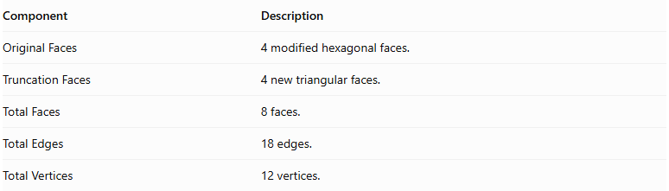
Component | Description
Original Faces | 4 modified hexagonal faces.
Truncation Faces | 4 new triangular faces.
Total Faces | 8 faces.
Total Edges | 18 edges.
Total Vertices | 12 vertices.

Face Composition
# Source: AI Source: Provided by: [Data Path: Persons Table -> ID Column: 1, Name_En Column: Motasem Essam] -> From: [ChatGPT] on [7/25/2026]
The truncated tetrahedron contains two types of polygonal faces:
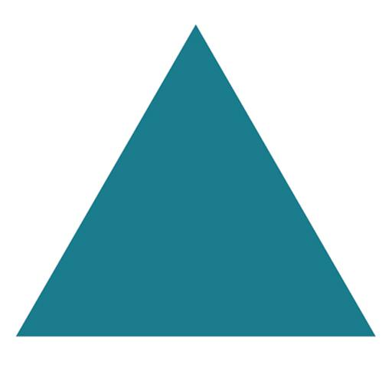

Triangular Faces
# Source: AI Source: Provided by: [Data Path: Persons Table -> ID Column: 1, Name_En Column: Motasem Essam] -> From: [ChatGPT] on [7/25/2026]
- Number: 4
- Shape: Equilateral triangles.
- Origin: Created by truncating the four original vertices.
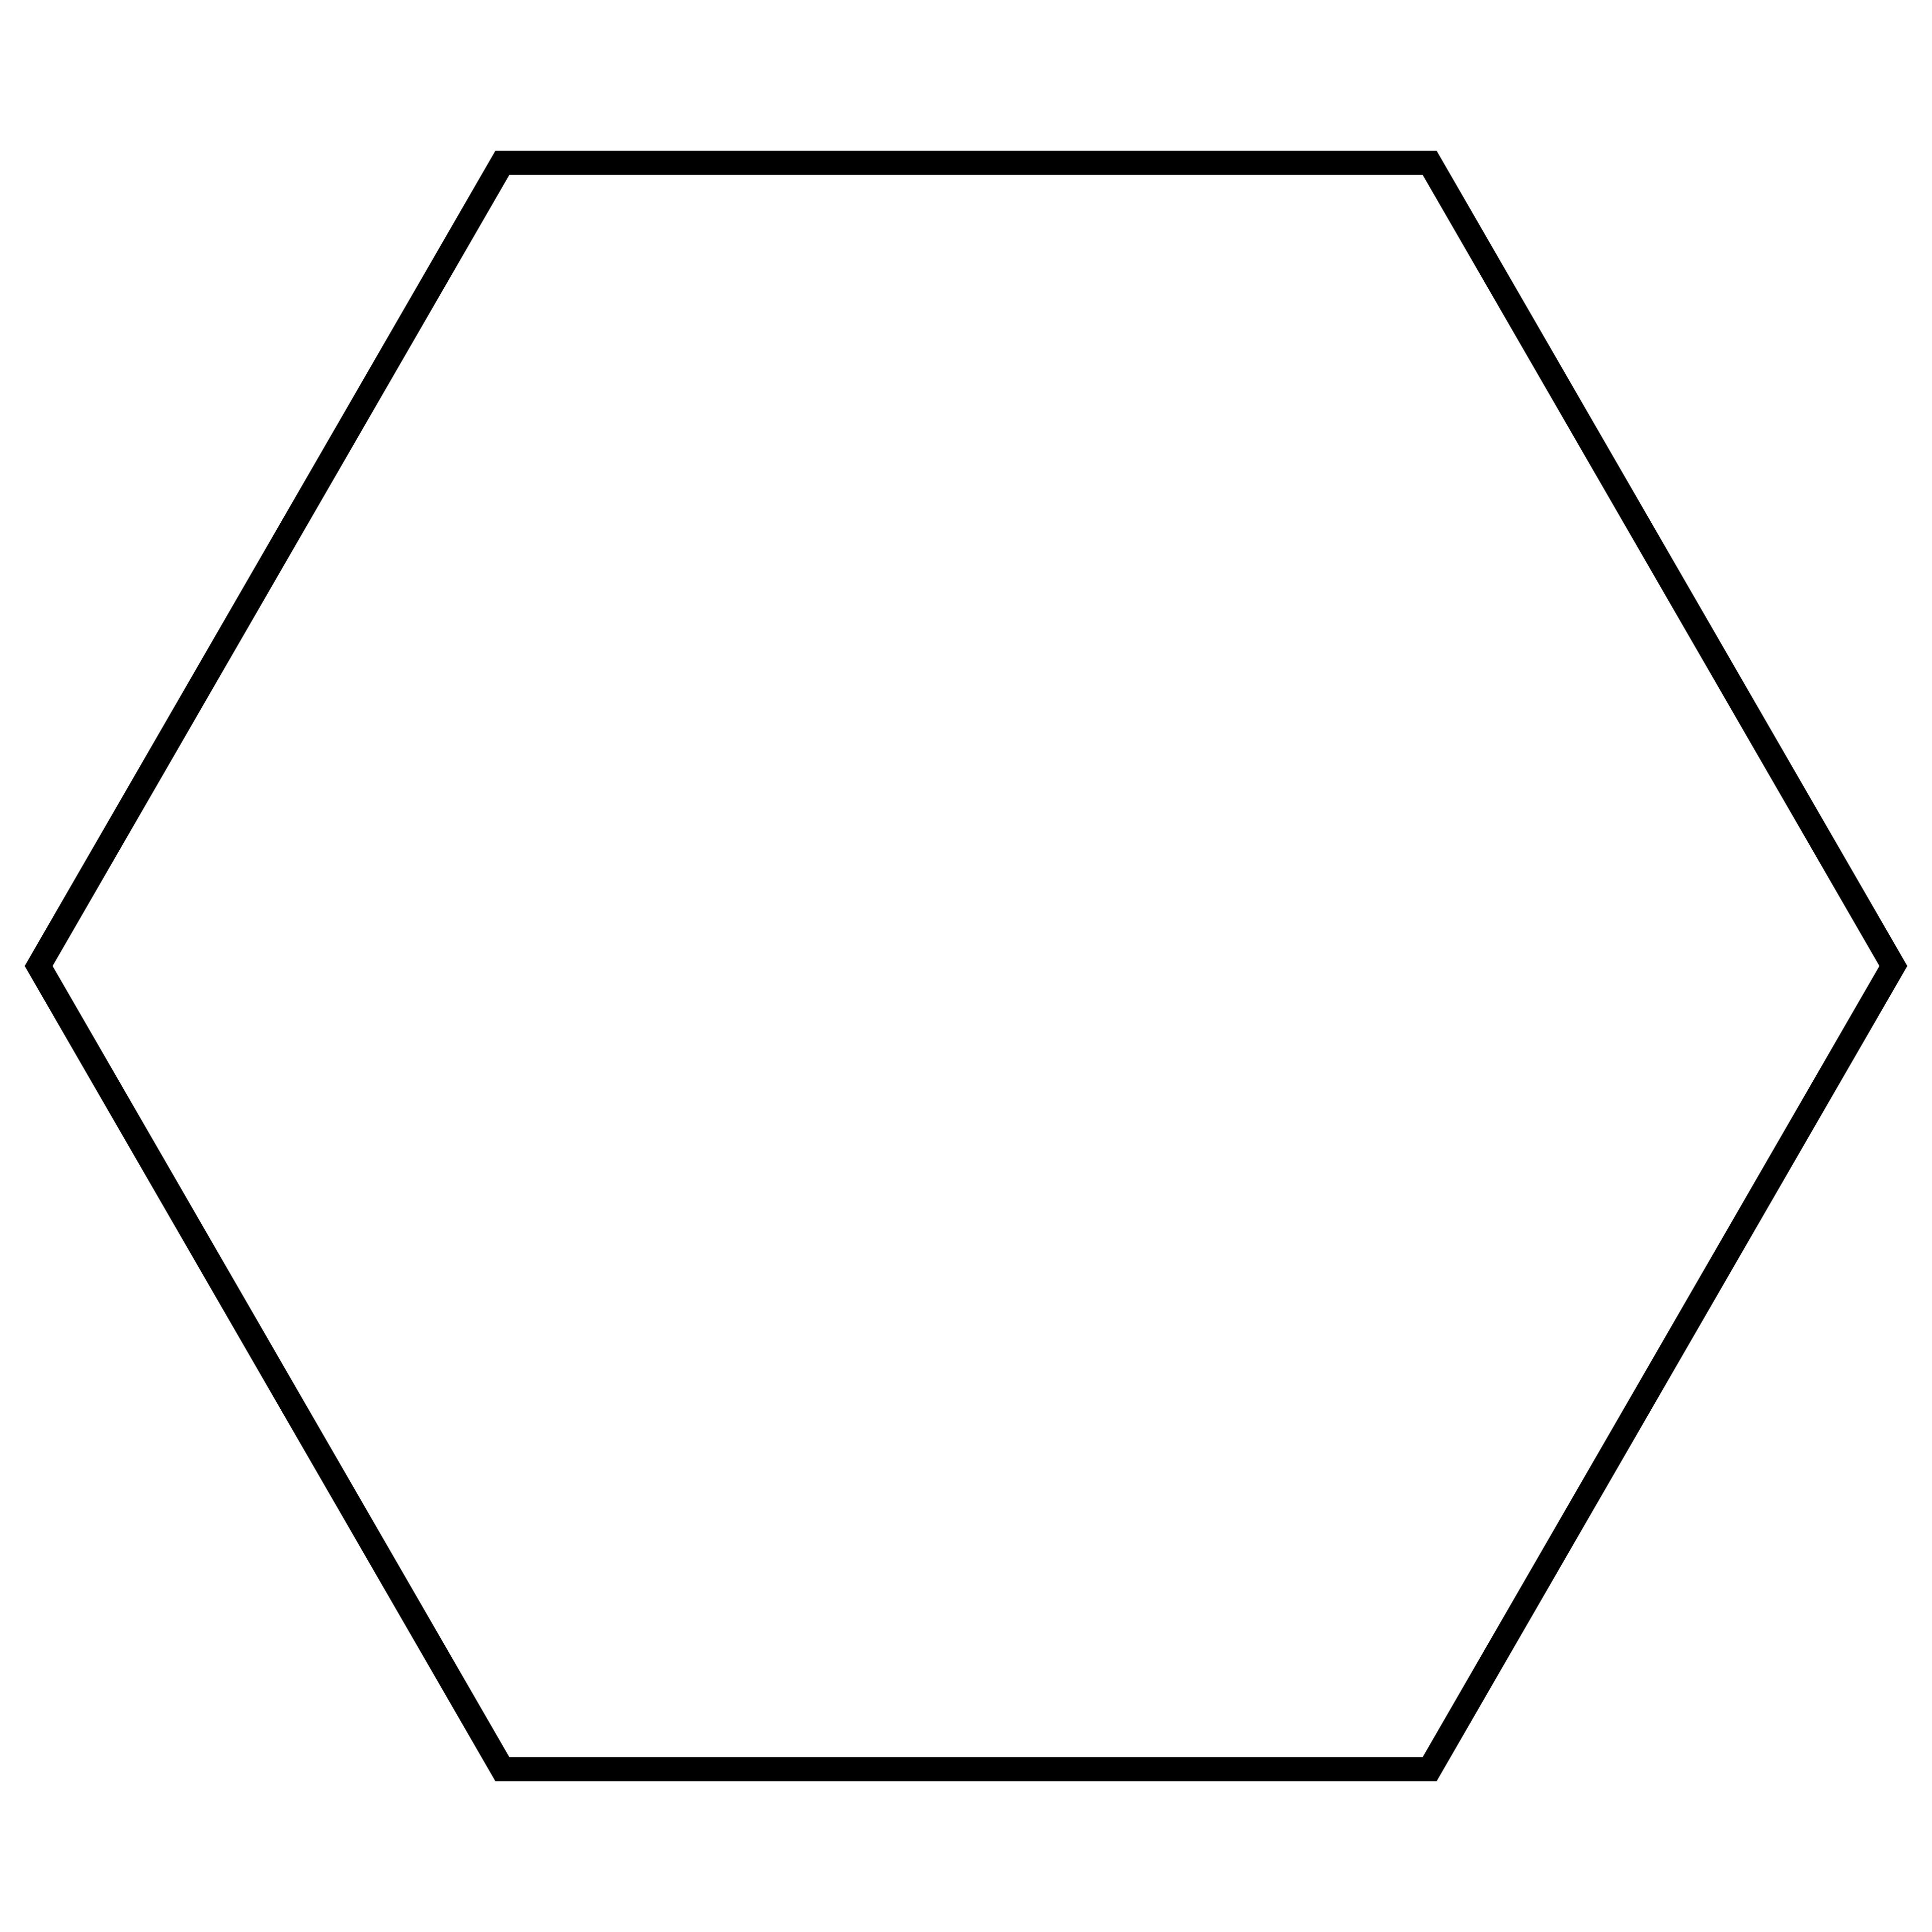

Hexagonal Faces
# Source: AI Source: Provided by: [Data Path: Persons Table -> ID Column: 1, Name_En Column: Motasem Essam] -> From: [ChatGPT] on [7/25/2026]
- Number: 4
- Shape: Regular hexagons.
- Origin: Modified from the four original triangular faces.

Mathematical Properties
# Source: AI Source: Provided by: [Data Path: Persons Table -> ID Column: 1, Name_En Column: Motasem Essam] -> From: [ChatGPT] on [7/25/2026]
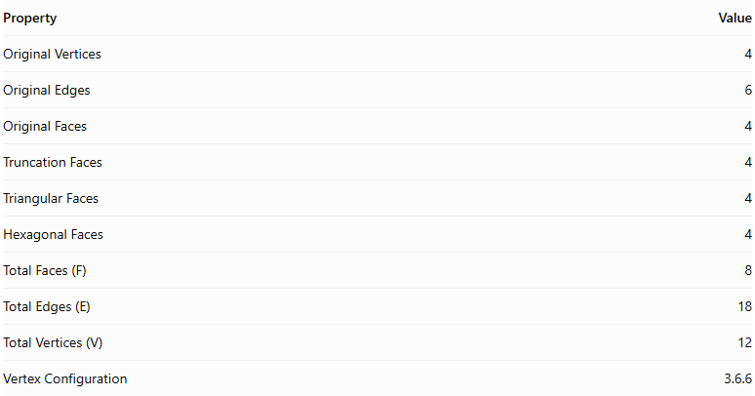
Property | Value
Original Vertices | 4
Original Edges | 6
Original Faces | 4
Truncation Faces | 4
Triangular Faces | 4
Hexagonal Faces | 4
Total Faces (F) | 8
Total Edges (E) | 18
Total Vertices (V) | 12
Vertex Configuration | 3.6.6
Euler's Formula:
$$V-E+F=2$$
Substituting:
$$12-18+8=2$$
Therefore, the truncated tetrahedron satisfies Euler's formula.

Key Points
# Source: AI Source: Provided by: [Data Path: Persons Table -> ID Column: 1, Name_En Column: Motasem Essam] -> From: [ChatGPT] on [7/25/2026]
- It originates from a regular tetrahedron.
- All four original vertices are truncated.
- It has 4 triangular faces and 4 hexagonal faces.
- It contains 18 edges and 12 vertices.
- It is an Archimedean solid when uniformly truncated.
- Its faces are regular polygons.

Conclusion
# Source: AI Source: Provided by: [Data Path: Persons Table -> ID Column: 1, Name_En Column: Motasem Essam] -> From: [ChatGPT] on [7/25/2026]
The Truncated Tetrahedron is an Archimedean solid formed by uniformly truncating the four vertices of a regular tetrahedron. It consists of four equilateral triangular faces and four regular hexagonal faces, with a total of 8 faces, 18 edges, and 12 vertices.

